**NAME: EMETUCHE WINNER CHIDIUTO**

**STUDENT ID: 18511160023**

**DATABASE COURSE PROJECT 2019/2020**

**DATABASE DESIGN CONCEPTUAL**

**LOST BUT FOUND WEBAPP**

Lofound is a database system which keeps record of lost properties around the university campus. It will be used by university students and staff to request and get details about a known item which was lost and found by a student or staff.

**Conceptual design** is the first stage in the database design process. The goal at this stage is to design a database that is independent of database software and physical details. The output of this process is a conceptual data model that describes the main data entities, attributes, relationships, and constraints of a given problem domain. This design is descriptive and narrative in form.

**Lofound Design Concept**

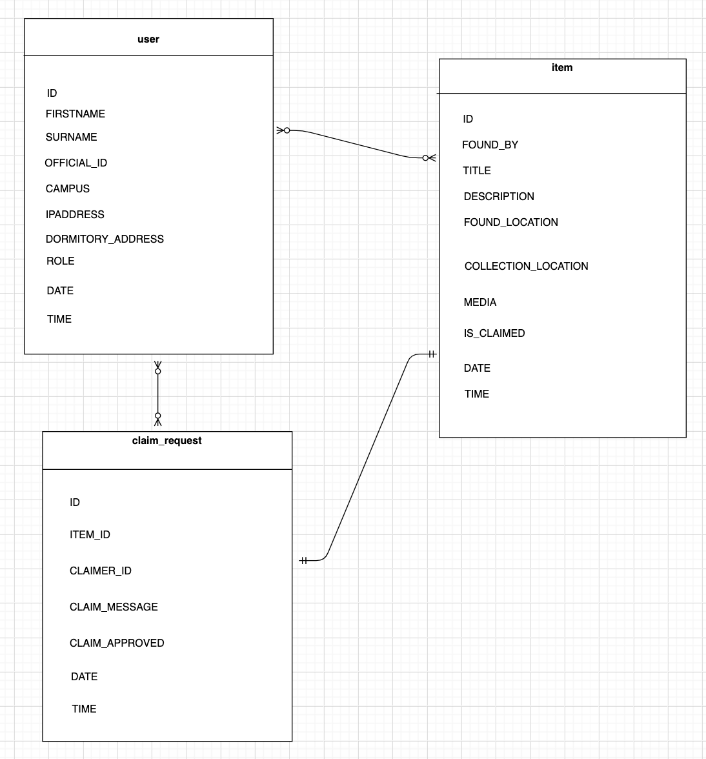

**System Interface Concept**

